Mansurbek Satarov

Doctor Tai Cleveland

COMP 3324

WEEK 5 – Lab TRIPWIRE

3/19/2023

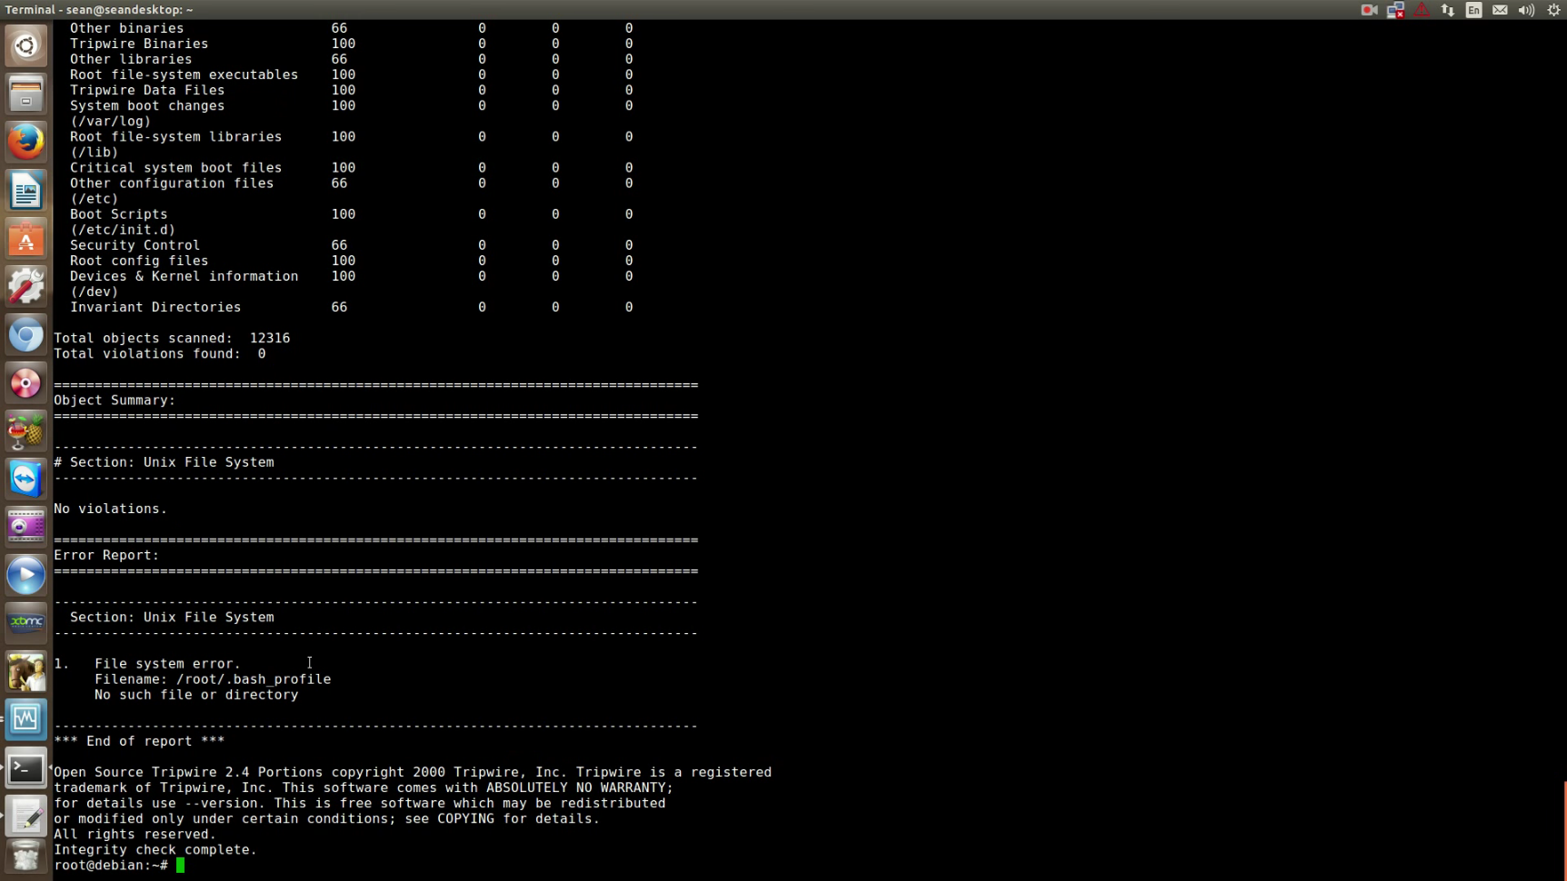

# What I learned:

* Tripwire is a free software security and data integrity tool for monitoring and alerting on specific file changes on a range of systems.
* Here tripwire is set on Debian GNU/Linux
* I do not have a Linux OS, that is why on this project laptop of Sean is used.
* We checked the objects on the computer, and found 0 violations